

ONLINE LEARNING

Software Requirement Specification

– Hanoi, August 2022 –

Record of changeS

| Date | A* M, D | In charge | Change Description |
| --- | --- | --- | --- |
| 15/5/2023 | A | Manhpthe170244 | Tạo tài liệu Srs |
| 15/5/2023 | A | Manhpthe170244 | Thêm Screen Details |
| 31/05/2023 | A | Manhpthe170244 | Thêm Post Details và Course List |
| 31/05/2023 | A | Soncqhe170808 | Thêm functional Requirement cho register và login |
| 31/05/2023 | A | Anhpnthe163972 | Thêm homepage, postlist |
| 31/05/2023 | A | Anhvqhe153742 | Thêm Change Password, ResetPassword |
| 01/06/2023 | M | Manhpthe170244 | Chỉnh sửa screen details |
| 02/06/2023 | A | Manhpthe170244 | Thêm ERD |
| 04/06/2023 | A | Soncqhe170808 | Thêm functional requirement cho dashboard và my Courses. |
| 05/06/2023 | A | Anhpnthe163972 | thêm slider list, quiz lesson |
|  |  |  |  |
|  |  |  |  |
|  |  |  |  |

*A - Added M - Modified D - Deleted

Table of Contents

I. Overview 4

1. Introduction 4

2. System Functions 5

3. Entity Relationship Diagram 6

II. Functional Requirements 7

1. Common 7

a. User Login 7

b. User Register

c. Reset Password

d. Change Password

e. User Profile

f. Contact List

g. Send Message

h. Notification List 7

2. Public

a. Home 7

b. Posts List

c. Post Detail

d. Courses List

e. Course Details

f. Course Register

3. Learning

a. My Courses 7

b. Lesson View

c. Quiz Lesson

4. Learning

a. Quiz Handle 7

b. Quiz Review

5. Marketing

a. Dashboard

b.

c. Slider List

6. Sale

a. Post Details Edit 7

b. Sliders List Edit

c. Slider Details Edit

d. Registrations List

e. Registration Details

f. Analysis

7. Course Content

a. Courses List 7

b. New Course

c. Course Details

d. Subject Dimension

e. Price Package

f. Subject Lessons

g.Lesson Details

h. Notification List

8. Test Content

a. Questions List 7

b. Question Details

c. Question Import

d. Quizzes List

e. Quiz Details

9. Admin

10. Customer

1. My Registrations
2. My Courses
3. Lesson View

d. Quiz Lesson

7

# I. Overview

## 1. Introduction

This project is aimed at developing an online learning system which supports the organisation/expert to

build up & sell the online courses, supports the user to search - register - access online courses for

learning. This system support for the below types of user:

● Guest: unregistered users

● Customer: they are registered users who are actual customers or potential customers

● Marketing: the marketing members of the organisation

● Sale: the sale members of the organisation

● Expert: access & prepare the course/test contents as assigned by admin

● Admin: the organisation leader/manager, acts as the system administrator

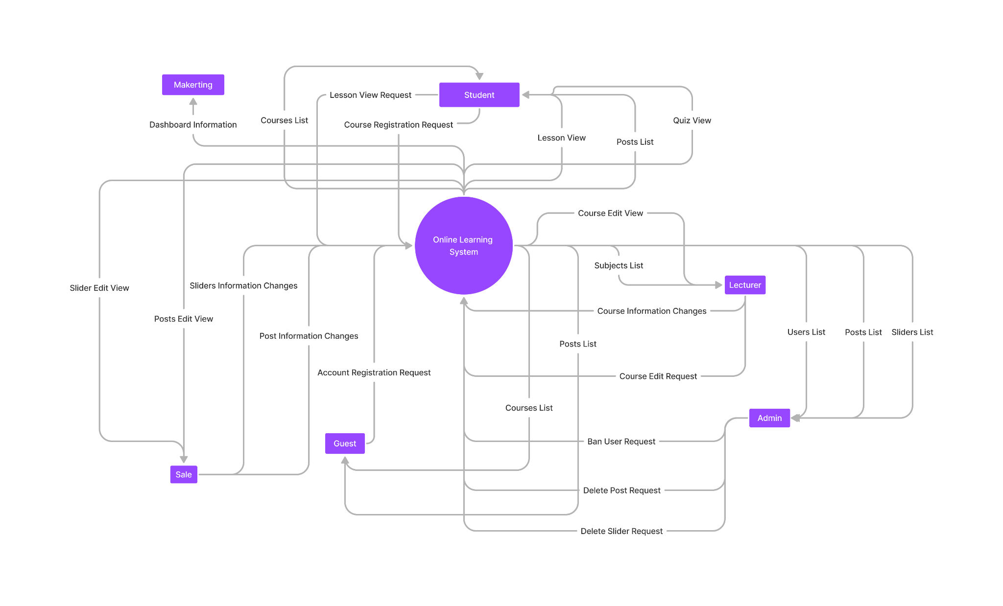

## 2. System Functions

#### a. Screen Flow

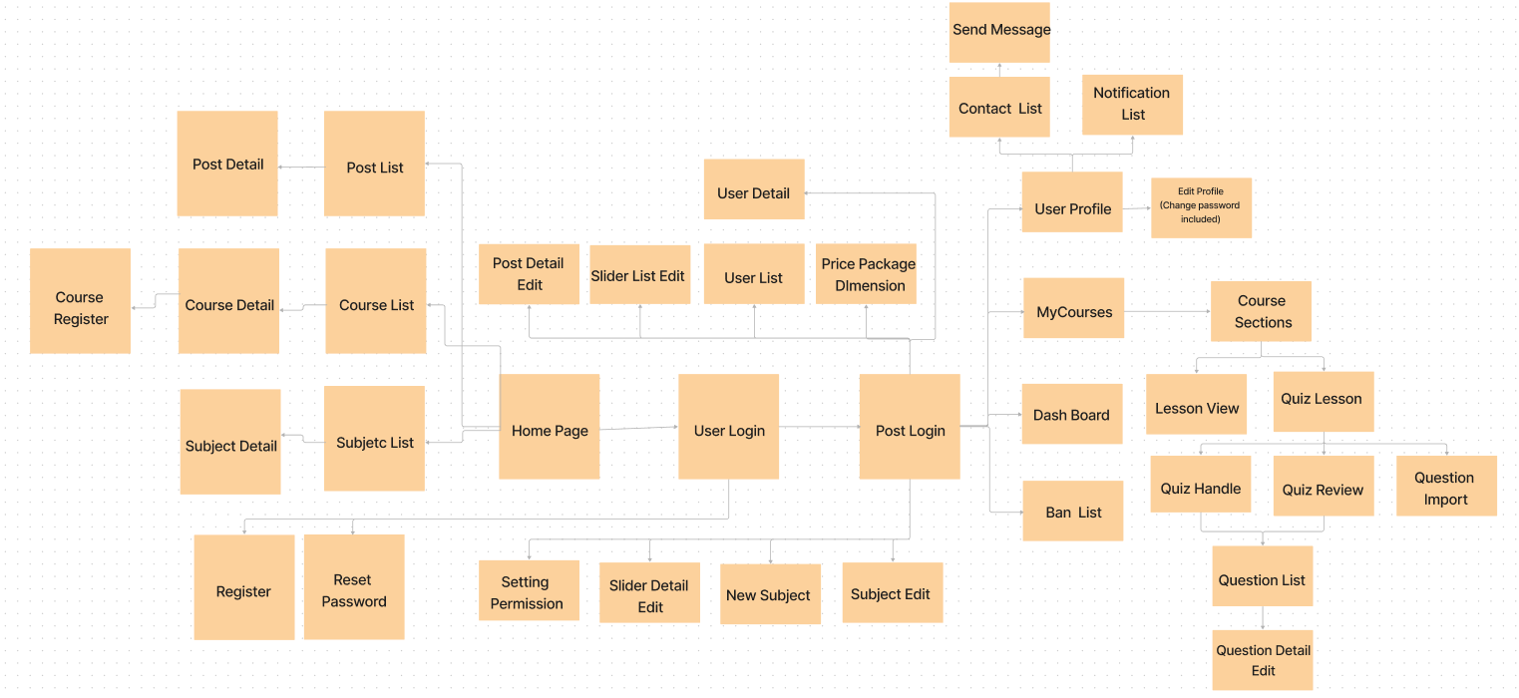

#### b. Screen Details

[Provide the descriptions for the screens in the Screens Flow above]

| # | Feature | Screen | Description |
| --- | --- | --- | --- |
| 1 | Common | User Login | This is a pop-up screen which allows the user to enter email & password to login; on this page, there are also options for users to register new information or reset the password in case s/he forgets it. |
| 2 | Common | User Register | This is a pop-up screen which allows the user to register himself/herself to the system by inputting following information: full name, gender, email, mobile; User then needs to verify by clicking the link sent via email to him/her before being able to access the system. |
| 3 | Common | Reset Password | The user input his/her email to receive the reset password link. This link is sent to the user's email for his/her password resetting.  - On clicking the link, the user is redirected to the password resetting page in which s/he input a new password (twice) for the system access.  - Note that the link is only available for a specific time duration as configured in the system config file. |
| 4 | Common | User Profile | This is a pop-up screen which allows the user to view his/her profile information, including the registered ones & the avatar image. Please note that s/he is not allowed to change the email |
|  | Common | User Profile Edit | This is a pop-up screen which allows the user to edit his/her profile information, including the registered ones & the avatar image. Please note that s/he is not allowed to change the email |
| 5 | Common | Change Password | This is a pop-up screen which allows the user to change his/her password by inputting his current password as well as new password (twice) |
| 6 | Common | Course Register | This is a pop-up screen which allows the user to register for access to a course. On this screen, the user needs to choose an appropriate course price package. |
| 7 | Common | My Courses | For the student to view his/her access-allowed courses |
| 8 | Common | Contact List | Show sider have the list of contact and block list, each contact contains a send message button and block button, click in contact to see contact history between 2 people, click send message button next to contact to go to Message Screen to send message. If click block button, block that user to message you and you can't message them either, you can go to block list and unblock usesr. |
| 9 | Common | Send message | Allow users to fill the receiver's email, subject, content and send that email. |
| 10 | Common | Notification List | Show notification, user can delete notification/ delete all notification/ delete readed notification. |
| 11 | Public | Home | Show sliders, hot posts, featured subjects + the slider with the latest posts, static contacts/links  - Shown slider information includes its image and title; the user is redirected to the slider's backlink on his/her clicking  - Shown post information includes its thumbnail, title, post date; the user is redirected to the post's details on his/her clicking  - Shown course information includes its thumbnail, title, tag line; the user is redirected to the course's details on his/her clicking. |
| 12 | Public | Posts List | Show the posts pagination (sorted by updated date) + the slider with the post search box, posts categories, latest posts, static contacts/links; Shown post information includes its thumbnail, title, category, brief-info; the user is redirected to the post's details on his/her clicking. |
| 13 | Public | Post Details | Show post details (including title, author, updated date, category, and post details) + the slider with the post search box, posts categories, latest posts, static contacts/links. |
| 14 | Public | Courses List | Show the courses paginated (sorted by updated date, paginated) + the slider with the course search box, course categories, and static contacts/links;  - Shown subject information includes its thumbnail, title, tag line, normal price package option (list price, sale price);  - The user is redirected to the course’s details on his/her clicking on the course. |
| 15 | Public | Course Details | Show subject details (including title, tag line, brief info, lowest price package option (original price, sale price), product description, and a Register button) + the slider with the subject search box, subject categories, featured subjects, static contacts/links. |
| 16 | Learning | Lesson View | Allow customers to access the course lessons for his/her studying. |
| 17 | Learning | Quiz Lesson | This allows the user to take the topic quiz or view the quiz results. |
| 18 | Learning | Quiz Handle | This screen allows the user to browse and answer the quiz questions and flag the important question for review. |
| 19 | Learning | Quiz Review | This screen allows the user to review the details of the quiz that s/he has just taken, and the user can see flag questions. |
| 20 | Marketing | Dashboard | Show statistics of new courses (new, all), revenues (total, by courses categories), customers (newly bought), and the trend of order counts by day for the last 7 days (the start date & end date can be adjustable). |
| 21 | Marketing | Post Details Edit | Show detailed post information (thumbnail, category, title, brief information, description, flag to turn the featurning on/off, status), from that allow the user to input, view or edit them. |
| 22 | Marketing | Sliders List Edit | Show the paginated list of sliders (including sliders' id, title, image, backlink, status).  - The user can filter the sliders by the status + search by title or backlink.  - For each slider, the user can choose to hide, show, edit it. |
| 23 | Marketing | Slider Details Edit | Show detailed slider information (image, title, backlink, status, notes). |
| 24 | Course Content | Courses List Edit | Show the list of course lecturers created. The shown information for each subject include the id, name, category, number of lessons, owner, and status  The user can:  - Filter the list by course category & status.  - Search the course by the name.  - Choose to add a new course (redirect the user to the New Subject page for that).  - Edit course information (linked to the Subject Details for that). |
| 25 | Course Content | New Course | The screen is shown with below information for the user to input new course information: name, thumbnail image, category, featured flag, owner, status, and description. |
| 26 | Course Content | Course Details Edit | This page allows the admin and the assigned expert to access and prepare the subject information, including the course general information, the dimension, and price package. Only the admin can change the status to Published or Unpublished + add/edit the price packages. |
| 27 | Course Content | Price Package Edit | This page allows the admin and sales to edit Price Package dimensions (Name, multiplier, duration, …) |
| 28 | Course Content | Lesson List Edit | This page shows the list of lessons for a selected package. On this page, the admin/expert is allowed to activate/deactivate, or call the Lesson Details for adding new or editing existing lesson |
| 29 | Course Content | Lesson Details Edit | This page allows the admin/lecturer to input/edit the lesson information |
| 30 | Test Content | Questions List Edit | The existing questions list for a specific subject/course are shown here (paginated). On this screen, the admin/expert is allowed to filter the questions by the subject, lesson, dimension(s), level, status + search the questions by content  Below information is shown for each question in the list: id, content, subject /dimension /lesson, level, status + options to show, hide, edit it; The page also allows the user to import the question (redirect him/her to the Questions Import pop-up screen. |
| 31 | Test Content | Question Details Edit | This page allows the admin/expert to input or edit questions information, including following information: subject, dimension(s), lesson, status, content, media (image, audio, video – with preview option), answer options (with the key marked + ability to add, edit, delete), and explanation. |
| 32 | Test Content | Question Import | This is a pop-up screen which allows the user to choose the import file and then import the questions in the file into the questions bank. The screen also provides the option for the user to download the sample import template. |
| 33 | Test Content | Quizzes List Edit | The existing quizzes are shown in this page pagination:  - Each quiz includes following information: id, name, subject, level, # question, duration, pass rate, and the quiz type.  From this page, the user has the option to call to the Quiz Details page for adding new or editing existing quizzes + delete the quiz. Please note that the quiz can be edited only when there is not any test taken yet. |
| 34 | Test Content | Quiz Details Edit | This page allows the user to input or edit quiz information |
|  | Sale | Package Register |  |
| 35 | Sale | Registrations List | Show the list of user’s registrations  - Each registration includes below information: id, email, registration time, subject, package, total cost, status, valid from, valid to.  - The user can filter the list by subject (searchable), registration time (from, to), status + can search by email.  - The list can be sorted by id, email, registration time, subject, package, total cost, status, valid from, valid to  - From the list, the user can choose to add new or edit an existing registration via the Registration Details screen as below. |
| 36 | Sale | Registration Details | Show detailed registration information (subject, package with list price/sale price, full name, gender, email, mobile), registration time, sale, status, valid from, valid to, notes) from that for the user to add new or change the status of a registration with relevant notes (if a registration is created by the user, then s/he can edit other registration information). On changing a registration status to Paid, if the user with relevant registered email does not exist, the system would create one and send back to the user the login information (link, email, pass) along with the other notification notes. |
| 37 | Admin | Ban/Report List | Include reported user list and reported course list, admin can reactively ban user or course, user get ban can view only and send message to ask admin to unban. |
| 38 | Admin | Settings List | Show the paginated list of settings (include settings' id, type, value, order, status):  - The admin can filter the setting by type, status.  - Allow the admin to search settings by value.  - The list is sortable by id, type, value, order, status  - From each setting, the admin can choose to view, activate/deactivate, or edit it.  - The page also has the button/link that allows the admin to add a new setting. |
| 39 | Admin | Setting Details | Show detailed user information (type, value, order, description, status), from that allow the user to add new, view or edit setting information. |
| 40 | Admin | Permission Setting | Show table of roles and permission, admin can tick in cell to enable permission for that role. |

#### c. User Authorization

[Provide the system roles authorization to the system features (down to screens, and event to the screen activities if applicable) in the table form as below – replace Role1, Role2,… with the specific system user role names]

| Screen | Guest | Customer | Lecturer | Marketing | Sale | Admin |
| --- | --- | --- | --- | --- | --- | --- |
| <<Login>> | X | X | X | X | X | X |
| Authenticate User | X | X | X | X | X | X |
| <<Register>> | X | X | X |  |  |  |
| Query All Data | X |  |  |  |  |  |
| Query Own Data |  |  |  |  | X |  |
| Query Managed Data |  |  |  |  | X |  |
| Add New Data |  |  |  |  | X | X |
| Update All Data |  |  |  |  |  | X |
| Update Own Data |  |  |  |  |  | X |
| Update Managed Data |  |  |  |  |  | X |
| Delete Data |  |  |  |  |  |  |
| … |  |  |  |  |  |  |

In which:

* Role1: <<role1 description>>
* Role2: <<role2 description>>
* …

#### d. Non-Screen Functions

[Provide the descriptions for the non-screen system functions, i.e batch/cron job, service, API, etc.]

| # | Feature | System Function | Description |
| --- | --- | --- | --- |
| 1 | Common | User Authorization | Implementation of authorization mechanism in the system, including the specify the role of logged-in user, his/her authorised page links (building the displayed menu items (in the front end) and preventing unauthorised access via enter the links directly) |
| 2 | Security | Encode password | Encoding password then save in database to ensure password security for users |

## 3. Entity Relationship Diagram

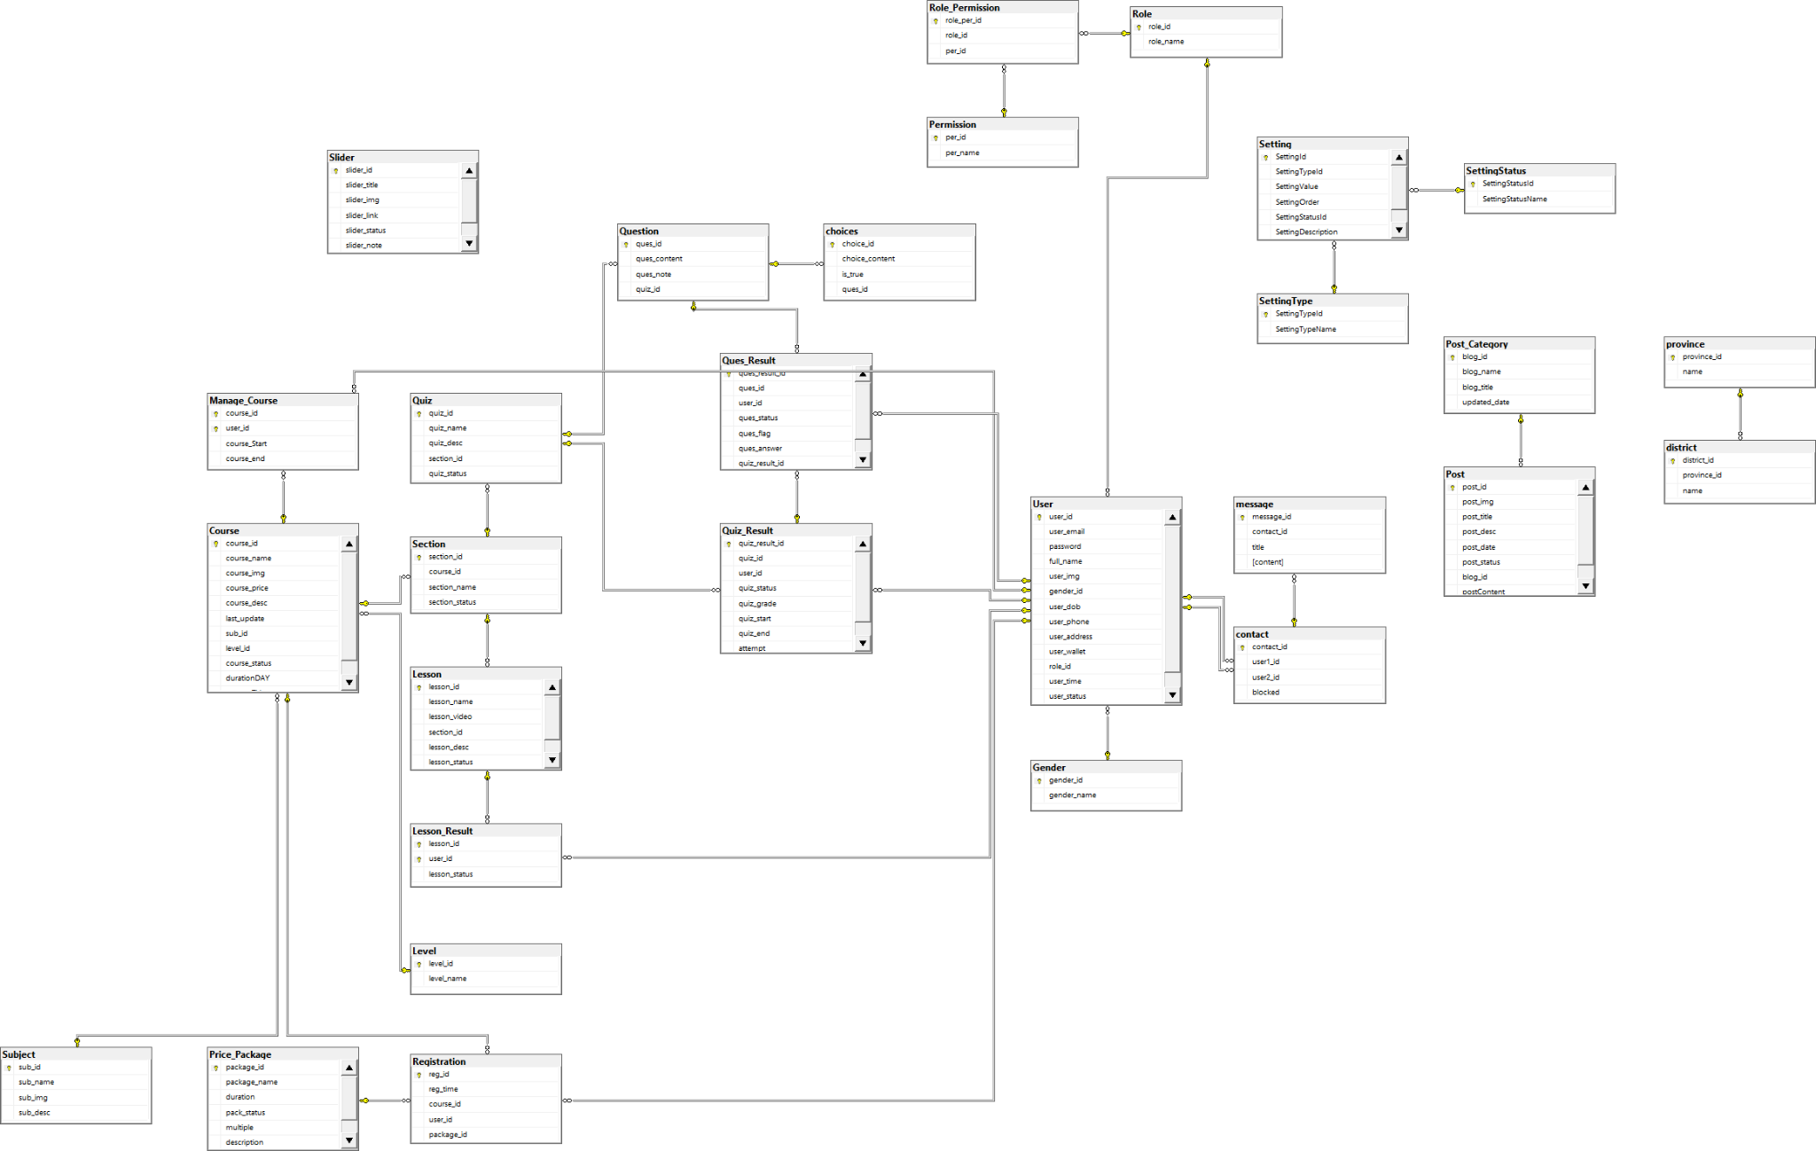

Entities Description

| # | Entity | Description |
| --- | --- | --- |
| 1 | User | Contains information about the user |
| 2 | Course | Contains information about the course |
| 3 | Manage Course | Shows the relationship between users who study which course |
| 4 | Choices | Show possible choice for each question |
| 5 | Contact | Shows the relationship between users have contact with each other |
| 6 | District | Contains names of each province’s districts |
| 7 | Province | Contains names of every province in Vietnam |
| 8 | Gender | Contains genders |
| 9 | Lesson | Contains Lesson information |
| 10 | Lesson_Result | Contains Lesson status is finish or not |
| 11 | Level | Contains level of course |
| 12 | Message | Messages of a contact |
| 13 | Permission | Possible Permission for each role |
| 14 | Post | Contains information about post |
| 15 | Post_Category | Sort post in category |
| 16 | Price_Pakage | Contains information about possible payment package |
| 17 | Ques_Result | Contains result of question every time user attempt quiz |
| 18 | Question | Contains list of question for each quiz |
| 19 | Quiz | Contains quiz information |
| 20 | Quiz_Result | Save result of each quiz attempts |
| 21 | Registration | Contains customer registration for course |
| 22 | Role | Contains role in website |
| 23 | Role_Permission | Show connection between role and permission |
| 24 | Section | Each course have multiple section |
| 25 | Setting | Contains information about setting |
| 26 | Setting_Status | Show setting status |
| 27 | Setting_Type | Contains setting type |
| 28 | Slider | Contains information about slider display in homepage |
| 29 | Subject | Each subject contains many course |

# II. Functional Requirements

## 1. Common

### a. User Login

### 

### 

| Function trigger: | The User can access the Login form via the ”trang ca nhan” link in the navigation bar at the top right of the screen. |
| --- | --- |
| Function description: | +Roles: All actors+Purpose: Authenticate users, allow users to access his information data and actions based on their role.+Data processing: The functionality uses data from table [User] of our database. |
| Lay out: |  |
| Detail: | The page will display a form that require user’s input on + User’s email + User’s password The user can choose to Sign up via the link below if they haven’t had an account yet. A submit button to submit the user’s input. After submitting, The program then check if the users’ input match the correct format+If the user input does not have the correct format, redirect back to login screen with an error notification. If the input is valid, the program then check if there is an user stored in the database with the given email and password+If not, redirect back to login screen with an error notification.After login successfully, redirect to the homepage. |

### 

### 

### b. User Register

### 

### Function trigger:

| Function trigger: | In the Login Screen, the user can access the register screen via a link below the login form. |
| --- | --- |
| Function description: | +Roles: Guests users+Purpose: Allow the unauthenticated users to be stored and viewed. Giving the users access to functionalities that would not be accessible for guests users.+Data processing: The functionality uses data from tables [User], [role],[gender], [province] and insert into table [User] of our database. |
| Lay out: |  |
| Detail: | The page will display a form that require user’s input on+ User’s email+ User’s password+ re-enter password+ User’s full name+ User’s profile picture(jpg, png,...) + User’s gender + User’s gender+ User’s date of birth+ User’s address(province)+ User’s phone number+ User’s wanted role The User Can choose to upload their local image file as their profile image The User can choose from a drop down list to assign their role, gender After submitting, The program then check if the users’ input match the correct format+If the user input does not have the correct format, redirect back to register screen with an error notification. If the input is valid, the program then check if there is an user stored in the database with the given email+If yes, redirect back to the register screen with an error notification.After registering successfully, redirect to the login page. |

## 

### c. Change Password

| Function trigger: | User can change password via link from profile page |
| --- | --- |
| Function description: | +Roles: Guests users+Purpose: Allows users to access data and change their passwords based on their roles+Data processing: The functionality uses data from table [User] of our database |
| Lay out: |  |
| Detail: | The page will display a form that require user’s input on+ User’s email+ User’s old password+ User’s new passwordThe User chooses to change password informationA submit button to submit the user’s inputAfter sending, the program will check if the old password and information match the formatIf the user information is not in the correct format, the wrong format message will appear and return to the original screenIf the user information is in the correct format, the program will check if it matches the data, if not, it will return to the original screen.If the information is formatted correctly, the database is correct, the page will report success and update the new information successfully |

### 

### d. Reset Password

### 

| Function trigger: | User can access the password reset form from the login screen |
| --- | --- |
| Function description: | +Roles: Guests users+Purpose: Allows users to access data and reset passwords based on their roles+Data processing: The functionality uses data from table [User] of our database. |
| Lay out: |  |
| Detail: | The page will display a form that require user’s input on+ User’s email+ User’s passwordThe User chooses to reset password informationA submit button to submit the user’s inputAfter sending, the program will check if the password and information match the formatIf the user information is not in the correct format, the wrong format message will appear and return to the original screenIf the user information is in the correct format, the program will check if it matches the data, if not, it will return to the original screen.If the information is formatted correctly, the database is correct, the page will report success and If the information is in the correct format, the database is correct, the page will report success and reset you a new password |

### 

### a. User Profile

### 

### 

| Function trigger: | Users can access their profile after logging into the course through the user profile link in the upper right corner of the screen. |
| --- | --- |
| Function description: | +Roles: User+Purpose: Allow users to view and edit his/her personal information related to the web+Data processing: The functionality uses data from table [User], Course and [Manage-Course] of our database. |
| Lay out: |  |
| Detail: | The page will display a web page which display:  * + User profile image   + Full name   + Gender   + Date of birth   + Phone number   + Address   + Budget   + Registration date   + And their registered course * The user can choose to Sign up via the link below if they haven’t had an account yet.   A log out button to log out the user’s account.After login successfully, redirect to the homepage. |

### 

## 2. Public

### HomePage

### 

| Function trigger: | In the Home Page, the user can access the register screen via a link below the login form. |
| --- | --- |
| Function description: | Roles: Guests usersPurpose: Allows users to view course overviewData processing: The functionality uses data from table [Course], [Posts], [Subject] of our database. |
| Lay out: |  |
| Detail: | The page will display a form displaying featured courses, current hot coursesUsers can view the types of courses, the most prominent courses.Click on the courses to see the details of that course |

### 

### b) Post List

### 

| Function trigger: | The Users can access to view each course |
| --- | --- |
| Function description: | +Roles: All actors.+Purpose: Show all courses+Data processing: The functionality uses data from table [Post], [PostCategory] of our database. |
| Lay out: |  |
| Detail: | The page will display all the courses for the user to viewClick search to find the name of each courseClick sort to filter, find courses by price, by name and by last updated date. Click on each course details to see more information described |

### c) Post Details

| Function trigger | The User can access the Post Details when clicking on a specific post in the post list screen or the new post slider at the bottom of the homepage. |
| --- | --- |
| Function description | +Roles: All actors.+Purpose: Show post detail to user.+Data processing: The functionality uses data from table [Post] of our database. |
| Lay out |  |
| Detail: | The Post Detail page is a webpage that displays the detailed information about a particular course or post.At the top of the page, there is a large title showing the name of the page “Post Details” . Below the banner image, there is a title showing the name of the post and the date it was published.The next section is the main content area, which contains the body of the course or post. This section includes text, images, and other multimedia elements and at the left corner is the link when a user clicks it will redirect back to the post list.Further down the page, there is a section for related posts. This section recommends other content that may be of interest to the user based on their current selection.Finally, at the bottom of the page, there is a footer section that contains links to other areas of the website, such as the home page, contact us, and about us pages. There are also social media buttons that allow users to share the content on various platforms. |

### d) Courses List

### 

| Function trigger | The User can access the course list when clicking on the button “Xem tất cả khóa học” in the subject filter at the middle section of the homepage. |
| --- | --- |
| Function description | +Roles: All actors.+Purpose: Show course list to user show by category and sort by price, name or last update date.+Data processing: The functionality uses data from table [Course] of our database. |
| Lay out |  |
| Detail: | At the top of the screen, there is a header section that contains a banner and a search bar. The search bar allows users to search for specific courses based on keywords or phrases.Below the header section is the main content area of the page. This section displays a grid of course cards that provide information about each course, including the course name, course image, course duration and course level. Courses are displayed by subject filter, user can click on a subject to view courses of that subject.In addition to the course cards, in the main content area, below the subject filter, there is also a sort bar, where users can choose to sort course by name, last update date or price.Last is section contains a pagination and a slider. The pagination allows users to see different pages of courses, helping to see all of the courses in the selected subject. The slider contains related courses. |

### e, Course Details

### 

| Function trigger | The User can access the course list when clicking on the |
| --- | --- |
| Function description | +Roles: All actors+Purpose: Show detail information for selected course from homepage or course list to user+Data processing: The functionality uses data from table [Course] of our database. |
| Lay out |  |
| Detail: | Below the header section is the main content area of the page, which also shows the source list for users.These courses show the subject details (including title, tag line, brief info, lowest price package option (original price, sale price), product description, and a Register button) + the slider with the subject search box, subject categories, featured subjects, static contacts/links.  * There a button “Đăng ký ngay” system will save course and user into [Manage Course] table in database |

### f, Course Register

| Function trigger | User can access this screen by click the button “Đăng ký gói” in homepage screen |
| --- | --- |
| Function description | +Roles: Student.+Purpose: Allow students to choose appropriate packages and upgrade their account.+Data processing: The functionality uses data from table [User], [Registration] and [PricePackage] of our database. |
| Lay out |  |
| Detail: | This is screen showing price package information  * Below the list of price package information is a button “Đăng ký” that will add data to the[Registration] table in the database that saves the user’s registration information. |

## 

## 3. Learning

### a, Quiz Handle

| Function trigger | User can access this screen by click the quiz in section of one course |
| --- | --- |
| Function description | +Roles: Student.+Purpose: Allow students to browse and answer the quiz questions and flag the important question for review and take the quiz.+Data processing: The functionality uses data from table [Quiz], [Quiz Result], [Question], [Question Result] and [Choice] of our database. |
| Lay out |  |
| Detail: | * First, at the top section display time remain and question list, each question display by a square button with number inside, answered question will be marked as green and flagged question will be marked as red * Second, at the top of main content section, show question, below are choices for that question, on the left and right are arrow buttons to move from question back and forward * In the last section is the finish attempt button, when user click it system will mark the quiz, show result and save the result |

## 

1. Lesson List

| Function trigger | Users access this screen by clicking on the course they want to choose |
| --- | --- |
| Function description | +Roles: Student +Purpose :Allowing students to choose from within a course+Data processing: The functionality uses data from table [Lesson] |
| Lay out |  |
| Detail | * The first shows all the lessons in a course. Allow students to choose the lesson they want to learn * After selecting the lesson you want to learn, click the trial lesson button, the screen will automatically switch to the lesson screen |

c. My Courses

| Function trigger | Users access this screen by clicking on the “KHOÁ HỌC CỦA TÔI” link on the navigation bar |
| --- | --- |
| Function description | +Roles: Student +Purpose :Allowing students see the courses that they are participating+Data processing: The functionality uses data from table [Users], [Manage_Course] and [Course] |
| Lay out |  |
| Detail | * The student can filter the subjects they want to search for by the subjects they belonged to. The program then perform a query to select from the manage course table, and course. * The User can also search by name of the course by inserting the name or part of the name of the course they are searching for. * The user then also sort the courses by their participate time and name by choosing on the drop down list. * By default, all the courses are displayed by the order that the student registered. After performing the sortings and filtering, the user can the courses that they are participating that satisfies the filter, or they will a message to notify them that there is no such course that they are participating in. |

d) Lesson View

| Function trigger | User can access the screen by clicking "Học" from Lesson List page |
| --- | --- |
| Function description | +Roles: Student + Purpose: Allow students to watch course teaching videos +Data processing: The functionality uses data from table [Lesson] |
| Lay out |  |
| Detail: | * This is the information display and teaching video of the course * Students can watch the video by clicking the Play icon, which has all the information of the lesson * Students who want to see previous lessons click the "Trước đó" button. If you want to see the next lesson click the "Kế Tiếp" button |

4. Marketing

DashBoard

| Function trigger | The Users with marketing role can access this screen by clicking on the “DashBoard” link in their profile page. The link is only visible to them and the admins. |
| --- | --- |
| Function description | +Roles: marketing, admin +Purpose :Allow the marketing department to get an overview of our service’s statistics so they can come up with proficient marketing plans+Data processing: The functionality uses data from table [Users], [Manage_Course] , [Course], [province], [registration(fixing)] |
| Lay out |  |
| Detail | * The marketer can see the service’s statistics in bar and line charts. * There are charts that represents to top most and top least(ex: top 5 courses with the most students). The user can toggle to view between the least or the most. * At the moment, there can only one toggle at a time so even if there are multiple togglable chart on our page, if you toggle 1, the other will be displayed in their default form which is top most. |

c. Slider List

| Function trigger | The Users with marketing role can access this screen by clicking on the “DashBoard” link in their profile page. The link is only visible to them and the admins. |
| --- | --- |
| Function description | +Roles: marketing, admin +Purpose :Allow the marketing department to get an overview of our service’s statistics so they can come up with proficient marketing plans+Data processing: The functionality uses data from table [Users], [Manage_Course] , [Course], [province], [registration(fixing)] |
| Lay out |  |

d, Slider Details Edit

| Function trigger | The Users with marketing roles can access this screen by clicking on the edit button in the slider list page. |
| --- | --- |
| Function description | +Roles: marketing, admin +Purpose :Show detailed slider information (image, title, backlink, status, notes)+Data processing: The functionality uses data from table [Slider] |
| Lay out |  |
| Detail | * Admin and marketer can access and edit the information of the page. They can decide to insert more information or delete the title, replay image,... * Only admin and marketer can edit the page |

e, Post Details Edit

| Function trigger | The Users with marketing roles or admin can access this screen by clicking on the edit button in the postListEdit page. The link is only visible to them and the admins. |
| --- | --- |
| Function description | +Roles: marketing, admin +Purpose :Show detailed post information (thumbnail, category, title, brief information, description, flag to turn the featurning on/off, status), from that allow to input, view or edit+Data processing: The functionality uses data from table [Post] and [Post Category] |
| Lay out |  |
| Detail | * Admin and marketer can access and edit the information of the post. They can add more post, including: title, image, date of the post,... |

10. Customer

d. Quiz Lesson

| Function trigger | The Users with marketing role can access this screen by clicking on the “DashBoard” link in their profile page. The link is only visible to them and the admins. |
| --- | --- |
| Function description | +Roles: marketing, admin +Purpose :Allow the marketing department to get an overview of our service’s statistics so they can come up with proficient marketing plans+Data processing: The functionality uses data from table [Users], [Manage_Course] , [Course], [province], [registration(fixing)] |
| Lay out |  |
| Detail | * The marketer can see the service’s statistics in bar and line charts. * There are charts that represents to top most and top least(ex: top 5 courses with the most students). The user can toggle to view between the least or the most. * At the moment, there can only one toggle at a time so even if there are multiple togglable chart on our page, if you toggle 1, the other will be displayed in their default form which is top most. |